**SOFTWARE**

**REQUIREMENTS**

**SPECIFICATION**

**FOR**

**WEATHER APP WITH DB**

**Prepared by:-**

**Shalini R**

**Sasika M**

**Premalatha P**

1. **Introduction**
   1. **Purpose**

The main purpose of this document is to layout the requirement of this system. The document will describe how the application will fetch the data in the need of taking information about weather worldwide. This document serves as a layout for the user interface, software and hardware dependencies. The SRS will serve as a reference for the development team for design, implementation and verification phases; the SRS is also an agreement between the client and the development teams regarding the functionality of the finished product**.**

* 1. **Document Conventions**
* Entire document should be justified.
* Convention for Main title
* Font face: Times New Roman
* Font style: Bold
* Font Size: 14
* Convention for Sub title
* Font face: Times New Roman
* Font style: Bold
* Font Size: 12
* Convention for body
  + - Font face: Times New Roman
    - Font Size: 12
  1. **Definitions, Acronyms and Abbreviations**

ER: Entity Relationship

SRS: Software Requirement Specification

Temperature related:

* °C: Degrees Celsius
* °F: Degrees Fahrenheit
* K: Kelvin

Precipitation:

* mm: Millimeters (measurement for rainfall)
* in: Inches
* %: Percentage chance of precipitation

Weather Condition:

* AM: Ante Meridiem (before noon)
* PM: Post Meridiem (afternoon or evening)
* WMO: World Meteorological Organization
* NWS: National Weather Service
* GIS: Geographic Information System
  1. **Scope of Development Project**

Application will collect weather data, analyze forecast readings, display output and help the users with their day, per conditions. It will display wind speed, humidity, temperature, day type and how the rest of the day will be like. System shows hourly and daily weather change, calculate weekly output and help the user with this wear according to the weather; give look ahead for the upcoming forecast change, and allergies that users might get. System also streams live map in iteration with weather change. User can send weather report to various social media platforms on their accounts, also send images and reports as personal messages. Accuweather can automatically detect user’s location, while user can also manually set or find locations to detect its weather, and get live updates through notifications.The product also provides the functionality to set weather units according to the user’s preference, also allows the user to set severe weather alerts. It will cover global news of natural disasters and phenomenon. Hence, it helps the people relax, as they can easily know how the rest of the day’s weather would be, and can set plans accordingly

**2. Overall Descriptions**

**2.1 Product Perspective**

AccuWeather is an application that provides commercial weather forecasting services worldwide..itwill utilize ideas passed on weather USA (www.weatherusa.net) and the National Weather Service (www.weather.gov). Both of these sites use cameras to show live feeds of the climate in different areas.

**SYSTEM INTERFACE**

The user interface for the task will have a site that will have the live feed alongside the data about the climate. This site will utilize HTML and ASP alongside CSS to add color and request to the site.

**OPERATIONS**

The site will have a live video feed of the climate and furthermore a live status of the climate from a climate site. The video feed will be live and up-to-date. This administration targets giving disaggregated locale/square level data in eachagroecological sub-area on figure climate

**2.2 Product Function**

The Accuweather.com will gather and show the nearby climate information from the live video feed. It will likewise investigate the climate hypothesis to enable clients to analyze weather forcast. The Accuweather.com will likewise have a connection to a climate site where it will show the present temperatures alongside a 5-day forcast.

**FUNCTIONS**

* + Dissapation System
  + Evaluation Option For Users
  + Economical
  + Supervision And Review
  + Providing Information On Forecasted Weather & Agro-Met Advisory Services
  + user interaction programs -Conducted at State, District levelsThere are various functions

**2. Overall Descriptions**

**2.1 Product Perspective**

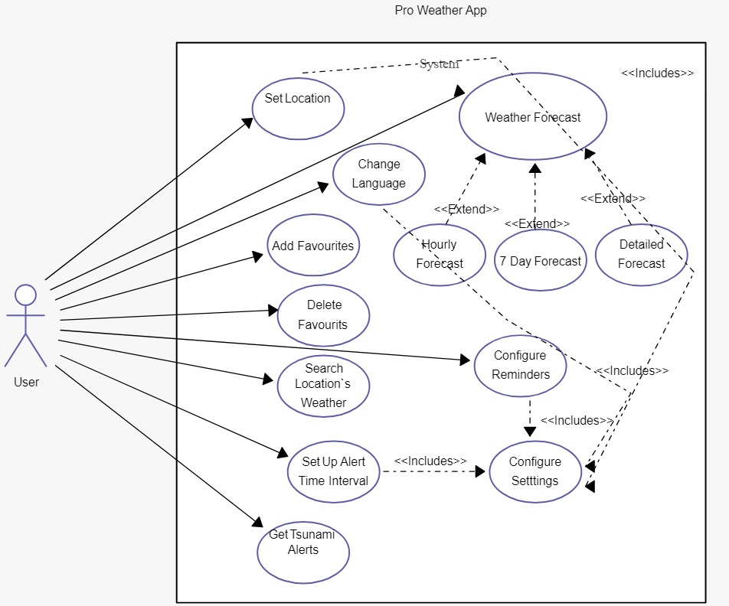

**2.3 User Classes and Characteristics**

The intended group for Accuweather.com wont require special expertise or any special experience

at all. They only require fundamental computing skills and fundamental knowledge of how to use

Internet web pages.

The intended group for Accuweather.com wont require special expertise or any special experience

at all. They only require fundamental computing skills and fundamental knowledge of how to use

Internet web pages.

The intended group for Accuweather.com wont require special expertise or any special experience at all. They only require fundamental computing skills and fundamental knowledge of how to use Internet web pages.

**2.4 Operating Environment**

Accurate weather is an weather update application. We can download it on any android/apple device . AccuWeather's forecasts and warning services are based on weather information derived from numerous sources, including weather observations and data gathered by the National Weather Service and meteorological organizations. This application is linked with Google maps so it can find our current location tell us about the weather, temperature etc. Since this is a weather forecast application, graphics don’t matter much but still accurate weather’s graphics are quite good. It takes 41 MB of total space

**2.5 Assumptions and Dependencies**

**Assumptions:**

One assumption about the product is that it will always be implemented and used on hardware devices that is the weather measuring instruments that have good performance.

**Dependencies**:

* Internal Dependencies : The product will be only depending upon hardware which is the only internal dependency that we have to care about
* Hardware Dependency: Some of the features of accurate weather will rely on some of the hardware components of the android mobile systems. First the app will be depending upon the memory of the android mobile systems. Therefore the product installation will be depending upon available storage memory in the android mobiles. It also depends on the location. We can manually put in our location to check weather. But we turn on our location services, things will be way easier.

**2.6 Requirement**

This section provides a detailed description of all inputs into and outputs from the system. It also gives a description of the hardware, software and communication interfaces and provides basic prototypes of the user interface.

**2.7 Data Requirement**

A first-time user of the weather app should see the log-in page when he/she opens the application. If the user has not registered, he/she should be able to do that on the log-in page. If the user is not a first-time user, he/she should be able to see the search page directly when the system is opened. Here the user chooses the type of search he/she wants to conduct.

Every user should have a profile page where they can edit their e-mail address, phone number and password

**3. External Interface Requirement**

**3.1 GUI**

This system will provide a graphical user interface. The layout of the system will be ahomepage of the app with a header on the top which displays the name of the website, under that their will be a navigation bar to go to related pages and have buttons to login and to go for help, under the navigation bar we have the main body which displays the live weather stream on one half of the page and displaying forecast on the other half, and at the end of the page their will be a footer which displays the contact information.

**Hardware Interfaces :**

Describe the logical and physical characteristics of each interface between the software product and the hardware components of the system. This may include the supported device types, the nature of the data and control interactions between the software and the hardware, and communication protocols to be used.

**Software Interfaces :**

The software interfaces that will be used are Visual Studio and SQL Management Studio. Visual Studio will be used for the coding of the app and for buttons. SQL management will be used to maintain the database to store the forecast. So that the weather can be stored and users can view them as they want and to give the overly month weather condition.

**Communication Interfaces:**

There are two interfaces that our system will interact with. 1. the weather channel website to provide the forecast.2. the camera that the live weather feed will come from.

**4. System Features**

User location and welcome

When the application is installed, user presses the icon and run it. Accuweather will display a

logo screen, and afterwards ask permission to locate the user automatically. If granted,

Accuweather will find the user location using the device’s GPS, otherwise, the user can

manually input his location by entering his desired city/state name

User location and welcome

When the application is installed, user presses the icon and run it. Accuweather will display a

logo screen, and afterwards ask permission to locate the user automatically. If granted,

Accuweather will find the user location using the device’s GPS, otherwise, the user can

manually input his location by entering his desired city/state name

User location and welcome

When the application is installed, user presses the icon and run it. Accuweather will display a

logo screen, and afterwards ask permission to locate the user automatically. If granted,

Accuweather will find the user location using the device’s GPS, otherwise, the user can

manually input his location by entering his desired city/state name

User location and welcome

When the application is installed, user presses the icon and run it. Accuweather will display a

logo screen, and afterwards ask permission to locate the user automatically. If granted,

Accuweather will find the user location using the device’s GPS, otherwise, the user can

manually input his location by entering his desired city/state name

* **User location and welcome**: When the application is installed, user presses the icon and run it. Accurate weather will display a logo screen, and afterwards ask permission to locate the user automatically. If granted, Accurate weather will find the user location using the device’s GPS, otherwise, the user can manually input his location by entering his desired city/state name.
* **Description and Priority:** For the user to get the area weather, it is must that he let the application detect his location or provide a location manually, so it can give the output of the desired area. This feature has the top priority without this app won’t run.

**5. Other Non-functional Requirements**

**5.1 Performance Requirements**

The performance should be able to support at least 10 simultaneous users. Data should be secured and backed up every day. Response time of the software is less than 5 seconds. Software should be opera table24 hours and accessible in real time . Actions are performed very quickly. This software application will not stuck and halt on any type of action.

**5.2 Safety Requirements**

Accurate weather will not damage or affect the other applications installed in the mobile phones and also not the performance of the mobile phone. The safety concerned with this software application that app should not been abled when your phone is used by any other person and if you are crossing a road or may be ride a bicycle/bike/car and engage in other activity.

**5.3 Security Requirements**

This software app will be use when the user enter the login ID and password .App is used by only one userat a time. If the user enter wrong ID or password more than 3 times the message alert to administrator which will resend the password and login ID to your mobile number after verifying that you are the using this application. The software allows conventions which allow for familiar location for menus and other things.

**5.4 Software Quality Attributes**

The graphical user interface (GUI) design by usability. The app is user friendly and organized in this style that user can easy to navigate. There will be notifications about the latest weather forecast and any updates regarding application. To ensure reliability and correctness there will be zero forbearance for errors in the algorithms. For flexibility and adaptability if the user disconnect with the internet or having weak connectivity the user still able to use the application till the connection established

**6. Other Requirements**

**Product Requirements**

Requirements which specify that the delivered product must be have in a particular way e.g.execution, speed, reliability, etc.

**Organizational Requirements**

Requirements which are a consequence of organization policies and procedures e.g. process standers used, implementation requirements, etc.

**External Requirements**

Requirements which arise from factors which are external to the system and its development process e.g. interoperability requirements, legislatives requirements, etc.

**Logical Database Requirements**

The information that will be put into the database are the photos (only if the system has progressed that far) and the database would be accessed daily if the photos are stored.

**6.2 Appendix**

**Analysis Models**

Includes any pertinent analysis models such as data flow diagrams, class diagrams, state-transition diagrams, or entity-relationship diagrams.

**6.3 Glossary**

This part involves acronyms and abbreviations used in the SRS

SRS: Software Requirements Specification

SQL: Structured query language

GPS: Geographical position system

DESC: Description

RAT: Rate in time

ERD: Entity-relationship diagrams

**Class Diagram:**